A242-Afr-Egy-Ushabti-New Kingdom-19th Dynasty-1293-1189 BCE-Blue Faience

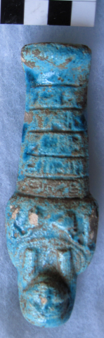

Fig. 1. Ushabti- Ushabti-New Kingdom-19th Dynasty-1293-1189 BCE-Blue Faience

**Case No.: 2**

**Formal Label:** Ushabti-New Kingdom-19th Dynasty-1293-1189 BCE-Blue Faience

**Display Description:** This New Kingdom Ushabti has a plain lappet wig with horizontal bands and holds two hoes.

**Accession Number: A 242**

**LC Classification:** DT62

**Date or Time Horizon:** New Kingdom-19th Dynasty-1293-1189

**Geographical Area: probably** Dayr al-Bari**, Thebes**

**Map, GPS Coordinates:** [25°43′14″N 32°36′37″E](https://tools.wmflabs.org/geohack/geohack.php?pagename=Thebes%2C_Egypt&params=25_43_14_N_32_36_37_E_type:landmark)

**Geographical Area: Luxor, Egypt-Valley of the Kings, Seti I, Tomb KV17**

**Map, GPS Coordinates:** [25°44′23.3″N 32°36′06.8″E](https://tools.wmflabs.org/geohack/geohack.php?pagename=KV17&params=25_44_23.3_N_32_36_06.8_E_type:landmark_region:EG)

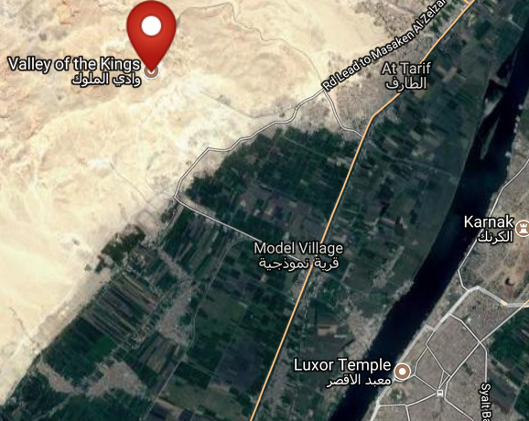 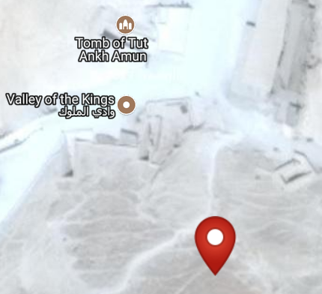

Figs. 3-4. Maps of KV17 from http://latitude.to/lat/25.73972/lng/32.60167

**Cultural Affiliation:** New Kingdom-19th Dynasty-1293-1189 BCE

**Medium:** blue faience

**Dimensions: H 127.39 mm; 5.01 in  
Weight: 84 g; 2 7/8 oz**

**Provenance: unknown**

**Condition:** original

When Seti I’s tomb, KV 17, was discovered by Giovanni Battista Belzoni in 1817, it contained more than 700 Ushabtis of wood, faience and glazed steatite. Since many of these Ushabtis were covered with bitumen, early visitors to the tomb would light the Ushabtis and use them as torches.

**References:**

Aubert, J.-F. et L. Aubert. 1974. *Statuettes Egyptiennes: Chaouabtis, Ouchebtis.* Paris, 1974.

Janes, Glenn. 2002. *Shabtis. A Private View, Ancient Egyptian Funerary Statuettes in European Private Collections.* Paris: Cybèle.

Newberry, Percy E. 1930-1957. *Funerary Statuettes and Model Sarcophagi.*  Le Caire: Impr. de l'Institut français d'archéologie orientale.

Porter, Bertha, R. L. B. Moss and E. W. Burney. 1964. *Topographical bibliography of ancient Egyptian hieroglyphic texts, statues, reliefs and paintings.* 1, The Theban necropolis 2, Royal tombs and smaller cemeteries. 2. ed., rev. and augmented, 1 Part 2. Oxford: Griffith Institute.

Schneider, Hans D. 1977. *Shabtis - An Introduction to the History of Ancient Egyptian Funerary Statuettes. With a Catalogue of the Collection of Shabtis in the National Museum of Leiden*. (3 volumes, Leiden: Rijksmuseum van Oudheden Te Leiden.

Schlögl, Hermann and Andreas Brodbeck. 1990. *Ägyptische Totenfiguren aus öffentlichen und privaten Sammlungen der Schweiz.* Orbis Biblicus et Orientalis, Series Archeologica, 7. Göttingen, Vandenhoeck & Ruprecht; Freiburg Schweiz, Universitätsverlag.